

Mechanical Engineering Department.

**Computer Project Number 4**

ME 554 Finite Element Analysis. Spring 2018

Instructor: Dr. Heidi Feigenbaum

Teaching Assistant: Dylan McAdams

Diego Ruiz

**Project Descriptions**

Assume that *k=*60 W/m-K for the steel, the top surface is held at 40 degrees C, the underside is held at 0 degrees C, and that no heat is lost form the sides. Solve this problem several different ways:

1. Using a 2D analysis where the whole structure is modeled.
2. Using a reduced 2D analysis where symmetry is used to reduce computational time.
3. Using a 2D analysis with a higher order elements (e.g. 8-noded quads).
4. Using a 3D analysis with 8-noded brick elements.
5. Using a 3D analysis with 4-noded tetrahedral elements.

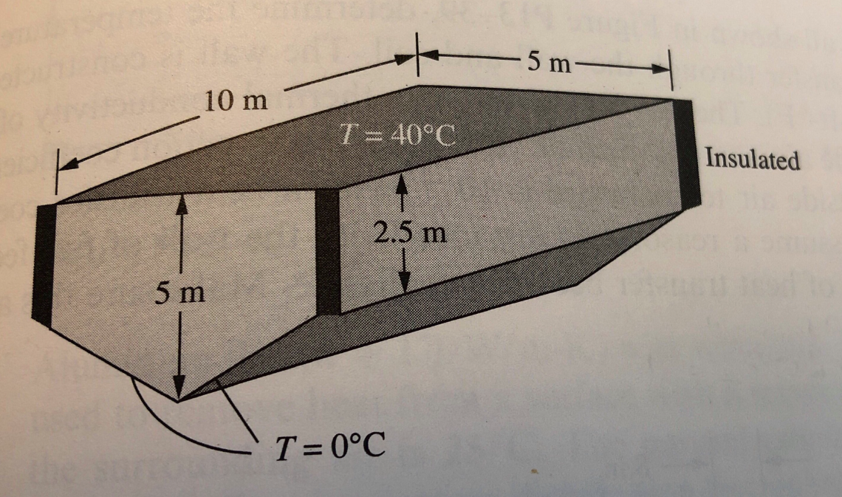

y

z

x

Figure 1

**Introduction**

In the pursuit of learning how FEA solves 2-D and 3-D problems, we are asked to solve a heat transfer problem for a given geometry. This problem will be solved with FEA methods for five different cases by implementation in ANSYS. Here, we will be able to learn how symmetry can be applied in FEA studies and how these symmetric simplifications can reduce a substantial amount of calculating time. Finally, we are going to evaluate how the results differ for these different cases.

**Model Development**

Assumptions:

* The material is consider isotropic
* 2-D and 3-D problems
* Linear interpolation
* Symmetry
* Limited number of nodes

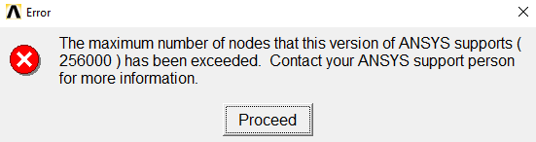

CASE 1

For the first case, I am going to consider a cross section area of this geometry through the y-direction. Based on the geometry and boundary conditions of the problems I expect to have the same temperature gradient along the y-directions but different temperatures in the x-z plane. The element type is Plane 55. Figure 2 shows the boundary conditions of this problem.

T = 40°C

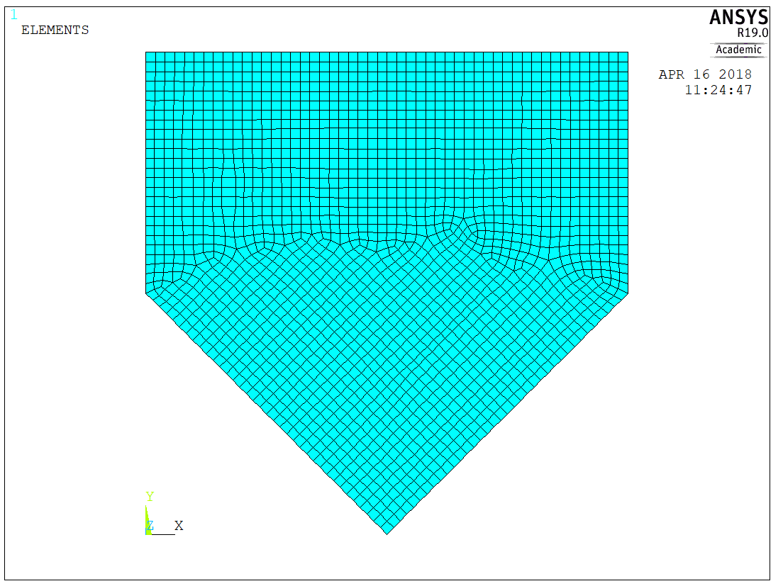

Figure 2

T = 0°C

CASE 2

A simplified case can be analyzed, where I consider only one-half of the previous case. Since symmetry is met, the results will be the same. The element type is Plane 55 (figure 3). The nodes in this mesh were distributed differently than in case 1; however the same number of nodes were set (Size element edge length is 0.2 m).

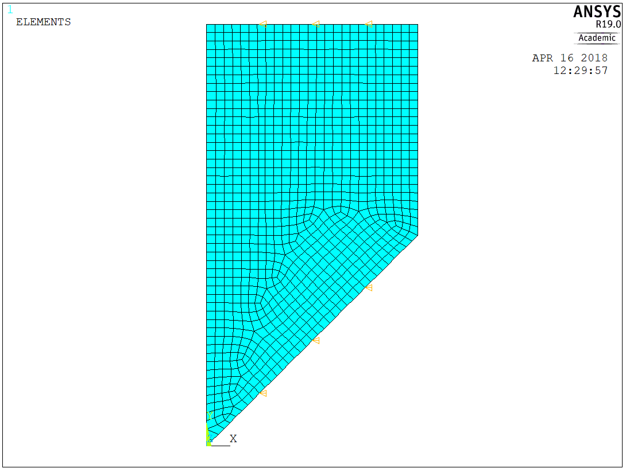

Figure 3

CASE 3

This case is similar to the case number 4, but a different type of element has been set (Quad 8 node 77). In addition, the mesh Size element edge length is 0.1 m.

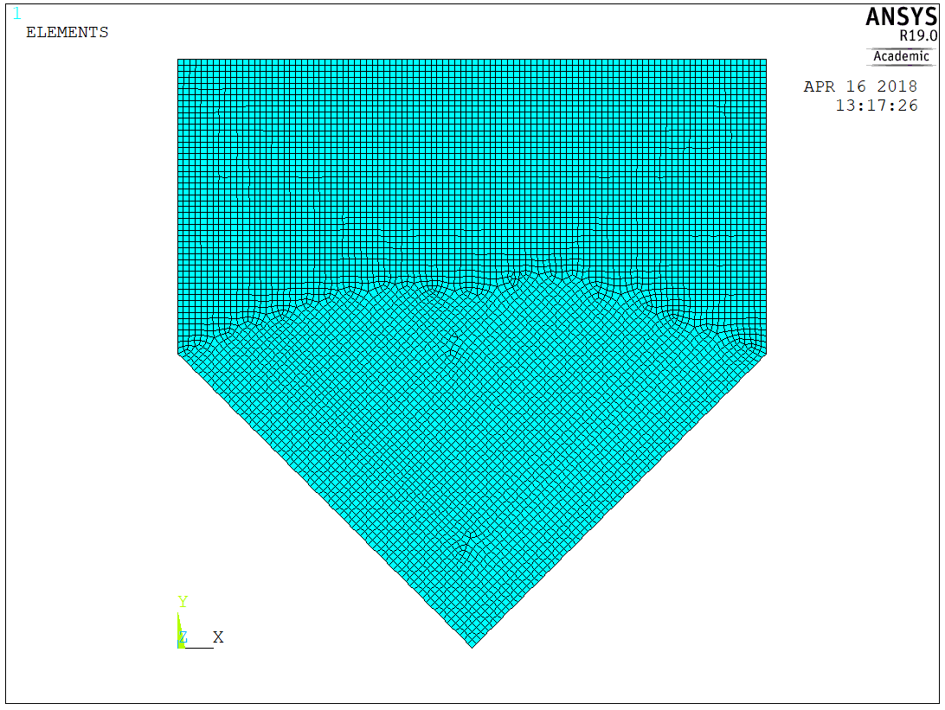

Figure 4

CASE 4

In case 4 and 5 we study exactly the same problem in 3-D. Since the this in class project is done with a Student ANSYS permission the total number of nodes is limited, for this reason the size element edge length used is 0.5 m. For this case, I set the element to be 8-noded brick elements; however the model does not show this type of element.

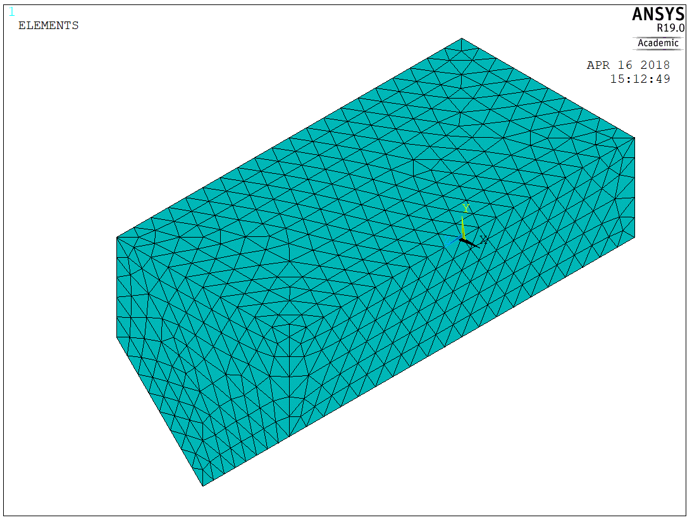

These elements should be brick elements but they do not look like that.

Figure 5

CASE 5

Similar case as the previous one, but the elements of this mesh are 10-noded tetrahedral elements and a size element edge length of 0.3 m.

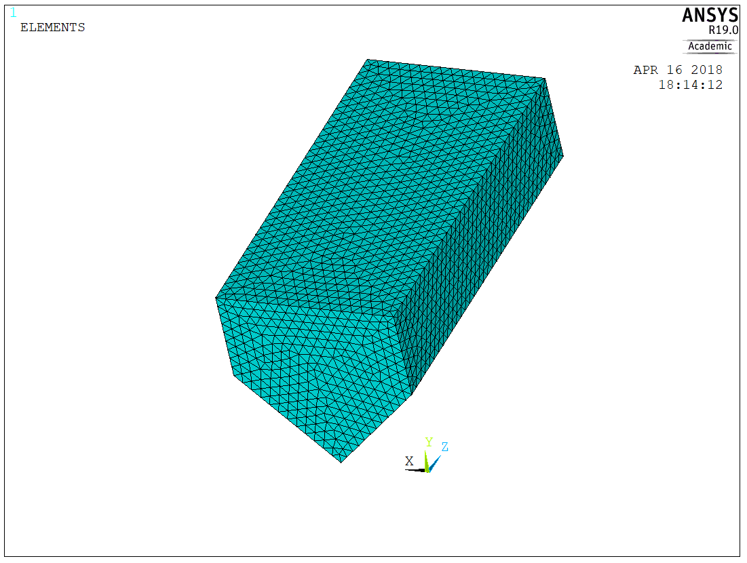

I could not find 4-noded tetrahedral elements, but 10-noded.

Figure 6

**Results**

**CONTOUR PLOT OF THE TEMPERATURE DISTRIBUTION AND HEAT FLUX**

CASE 1

Gradient temperature look as expected with a maximum on the top of 313 K and minimum at the bottom (figure 7). The maximum losses of heat transfer appear at the side corners (figure8).

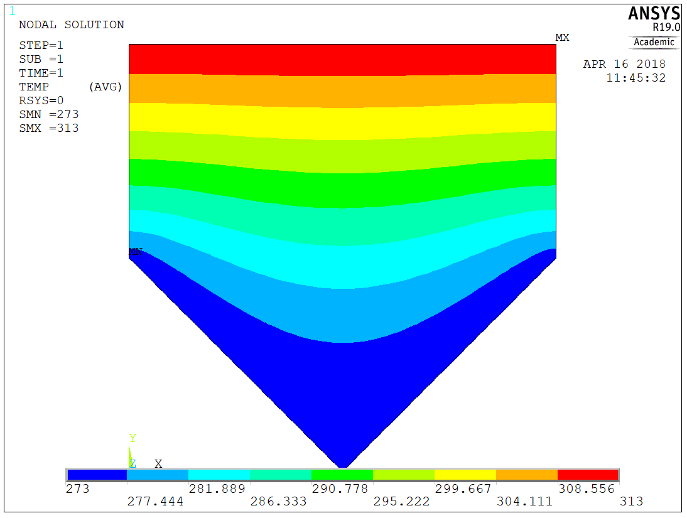

Figure 7

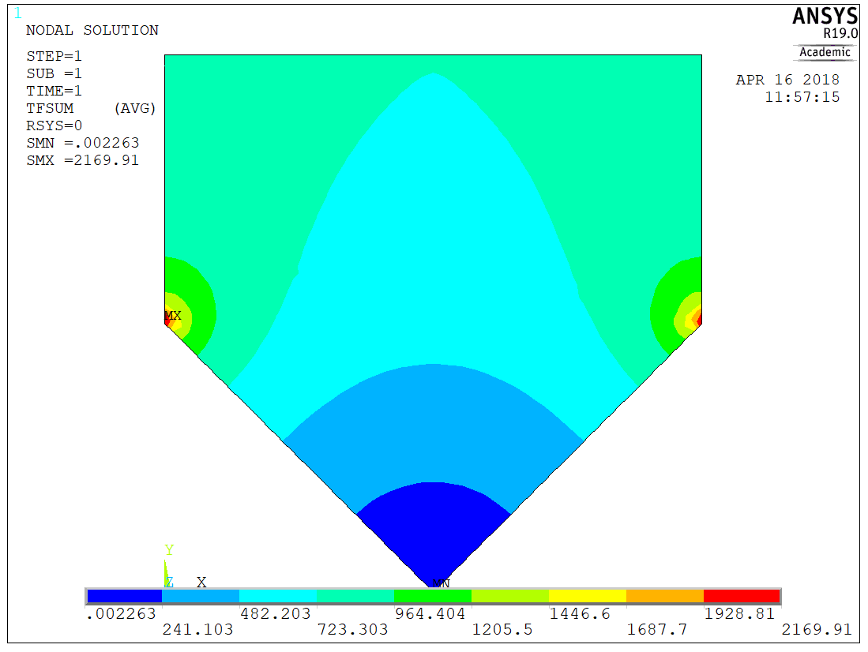

Figure 8

CASE 2

Same results as case 1 since it is symmetric. (Figure 9 and 10)

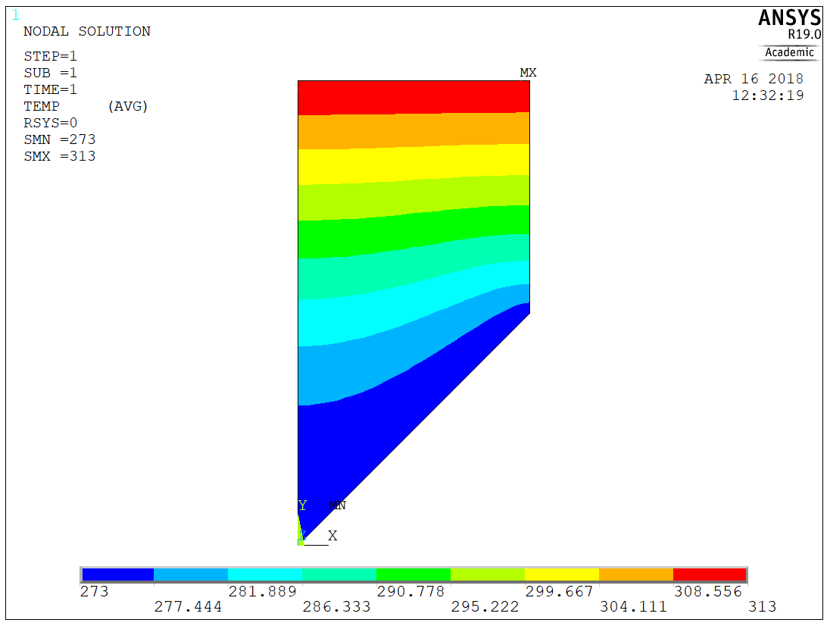

Figure 9

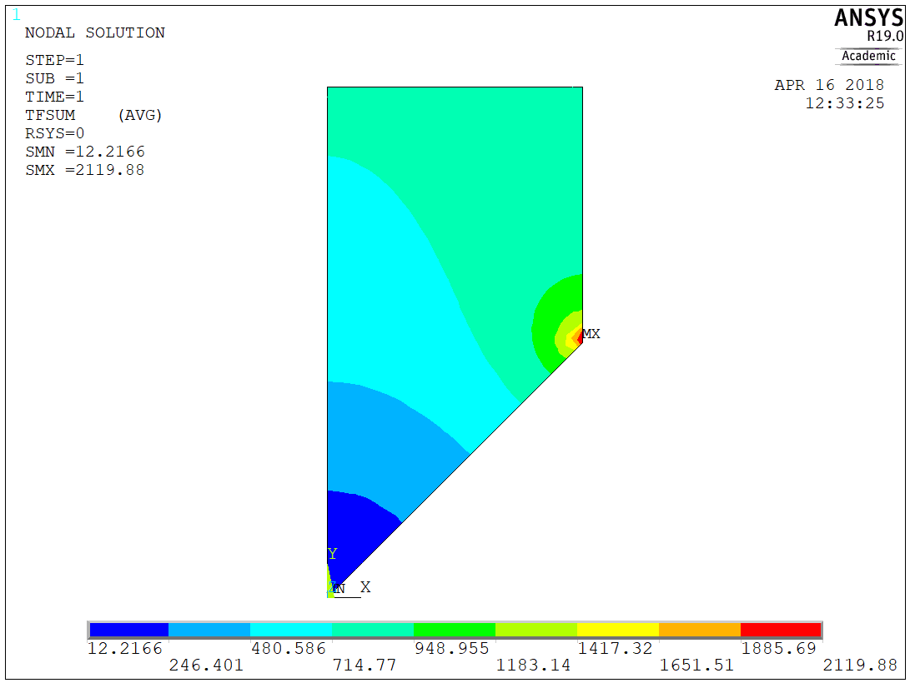

Figure 10

CASE 3

Results look similar to the cases 1 and 2, however, here more accurancy is attained.

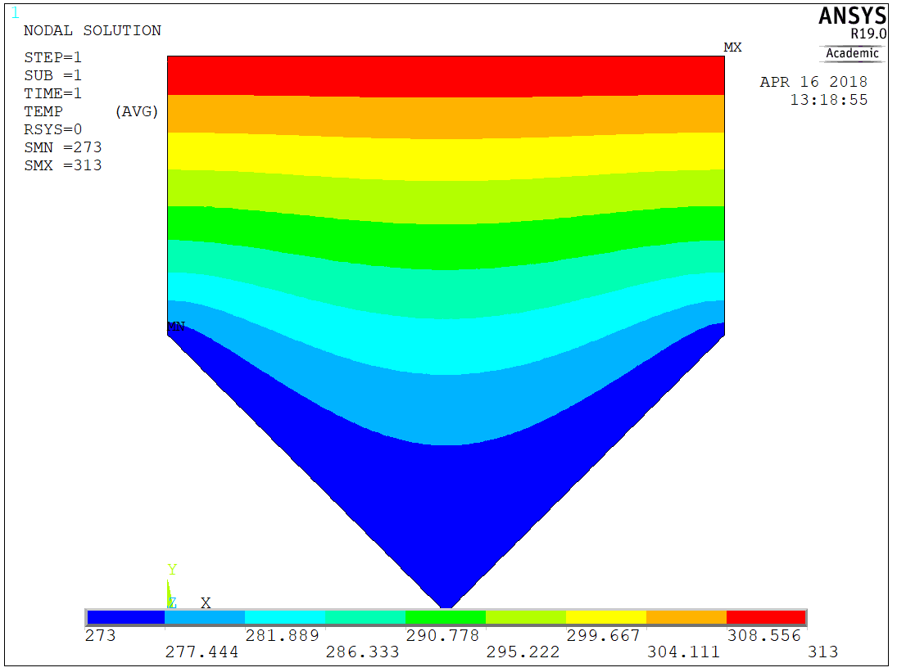

Figure 11

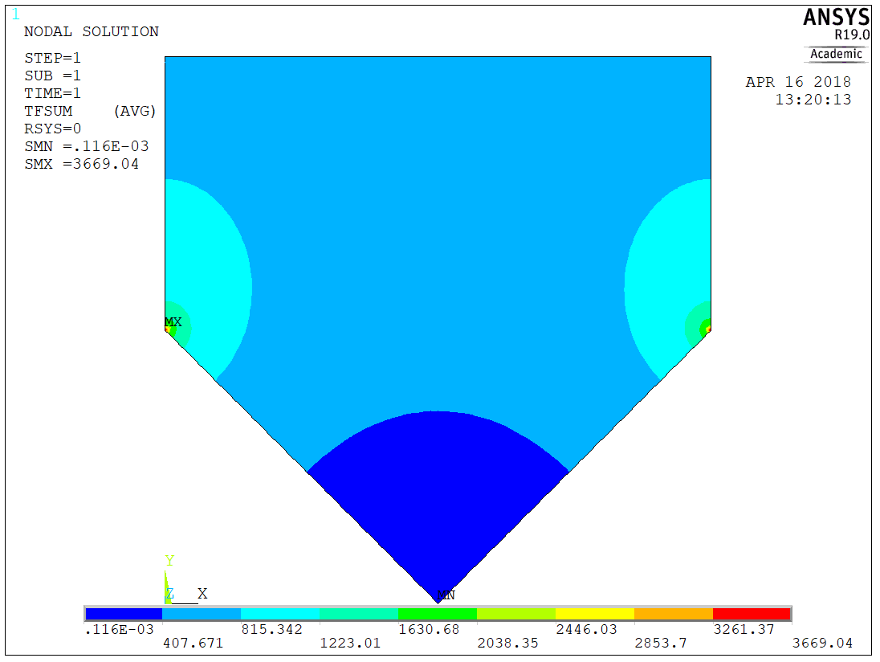

Figure 12

CASE 4

In this 3-D problem we still can see similar results (figure 13 and 14). Now, the results are less precise because simplification to a 2-D problem let us to increase the number of nodes, thus more accurate results are obtained for previous cases. A I would like to highlight the fact that the side edge look very irregular in the figure 14.

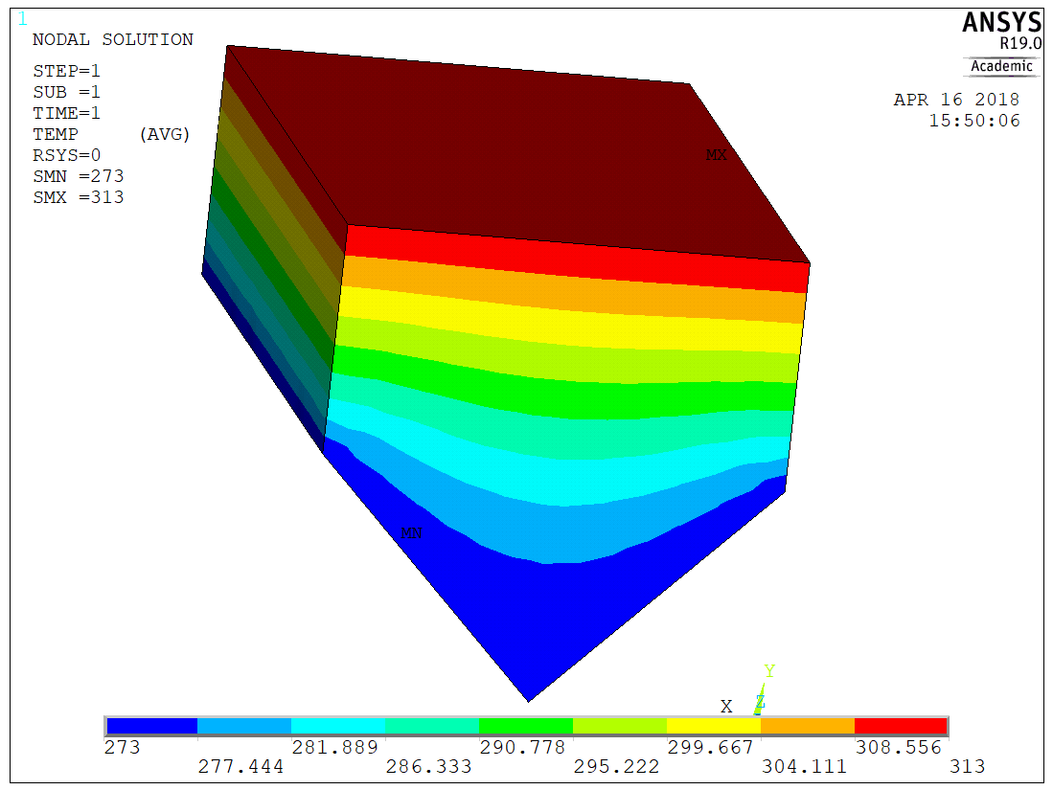

Figure 13

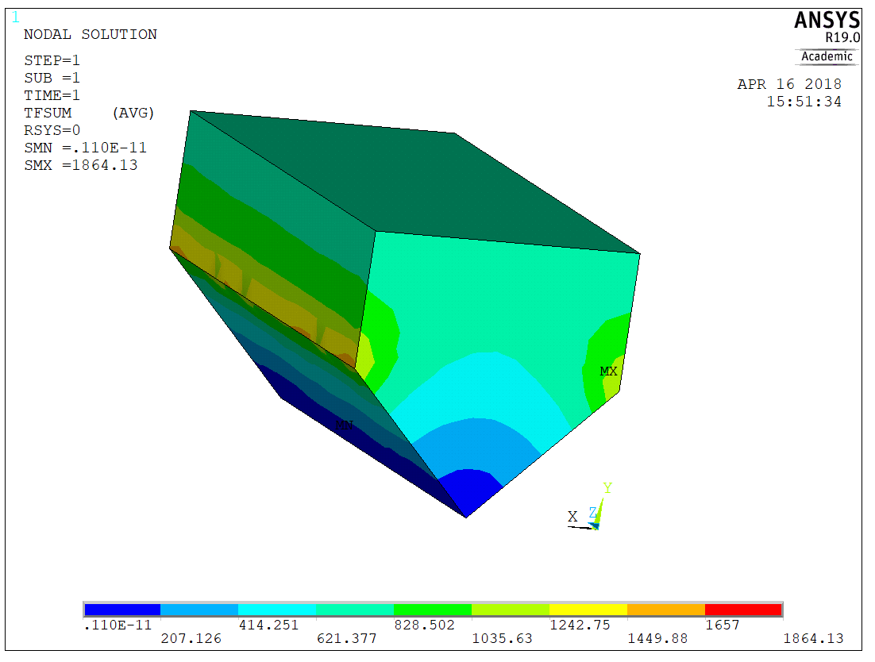

Figure 14

CASE 5

Similar results to the previous case. But higher level of precision due to change in elements and refine of the mesh.

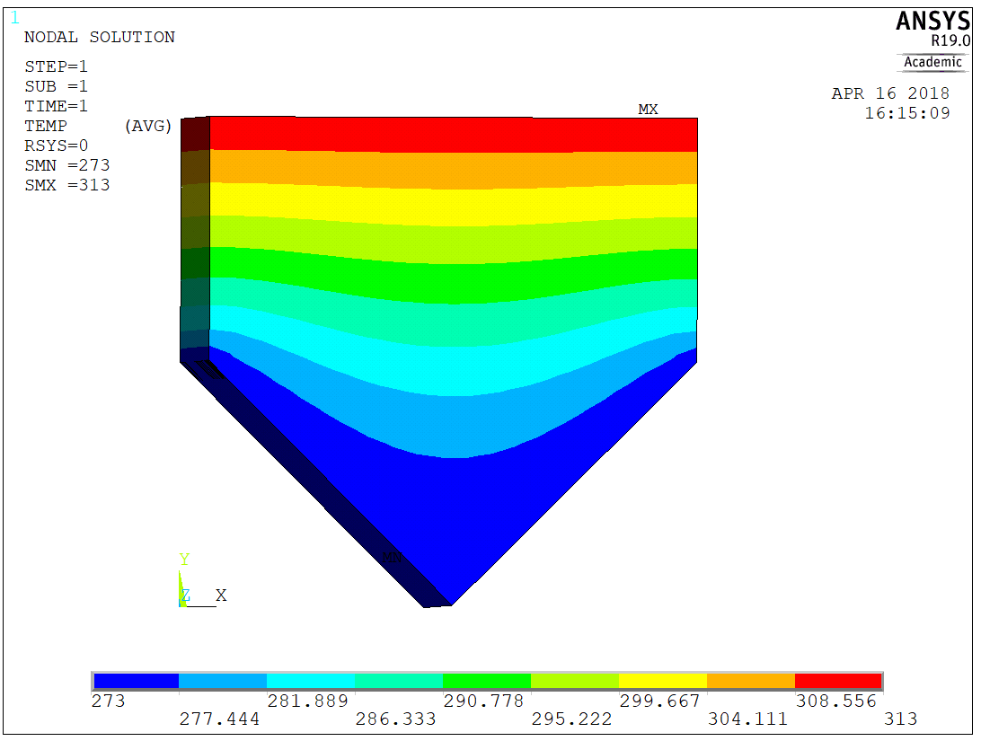

Figure 15

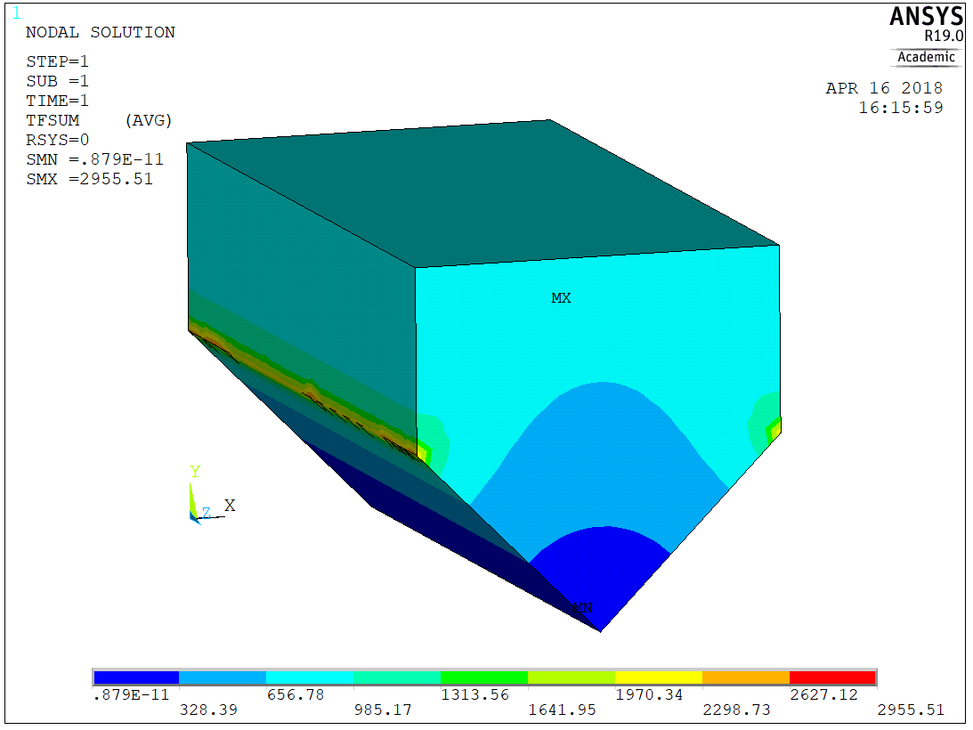

Figure 16

**LINE GRAPHS**

CASE 1

For the given line in figure

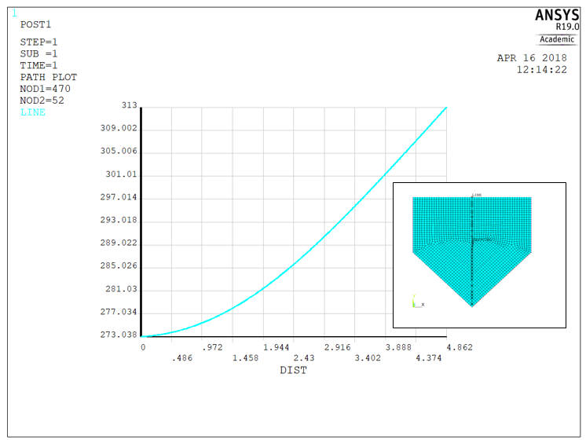

Figure 17

CASE 2

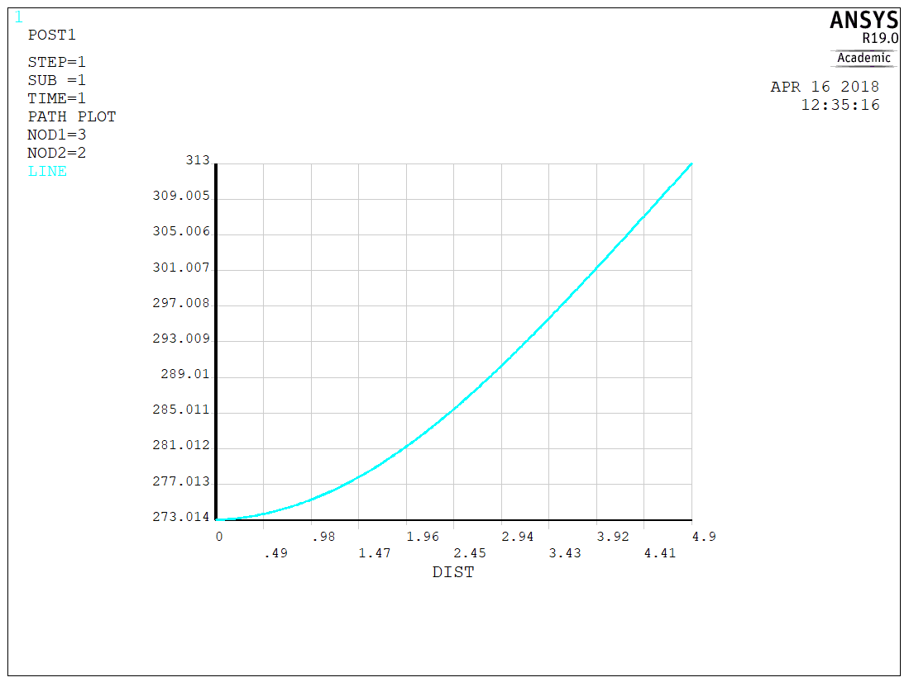

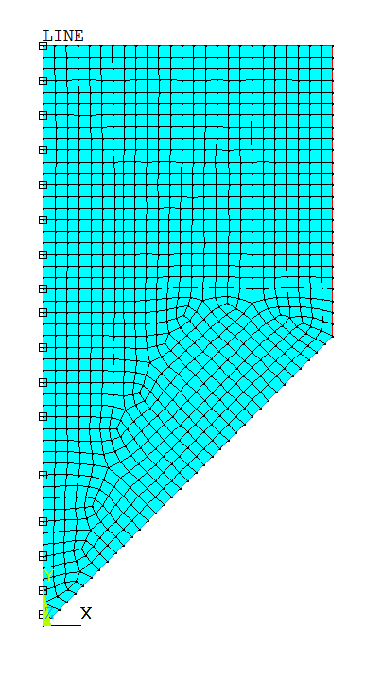

Figure 18

CASE 3

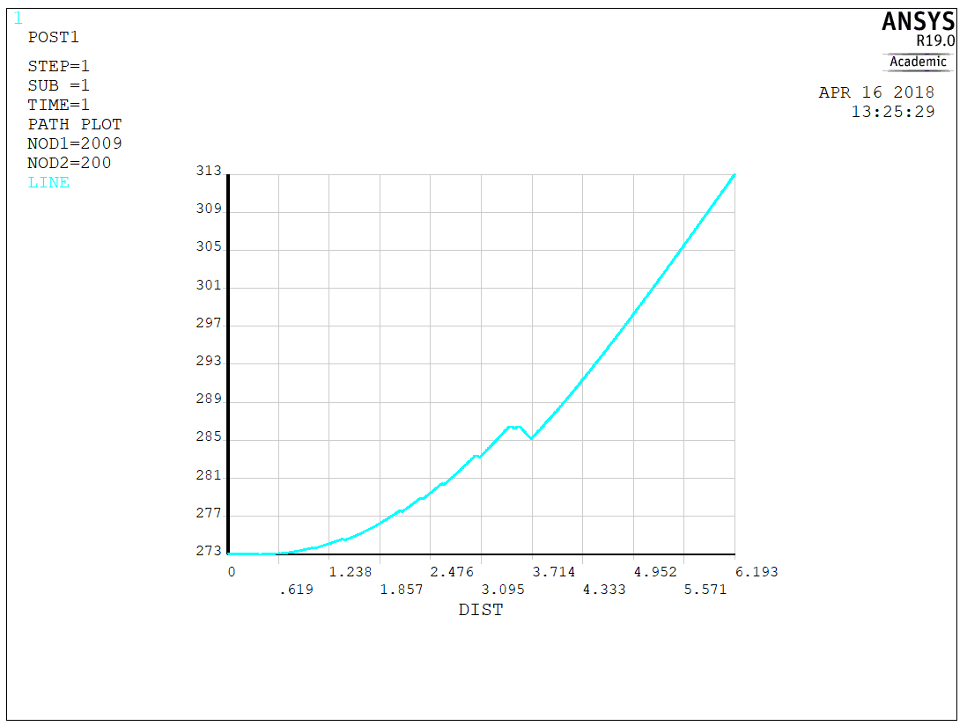

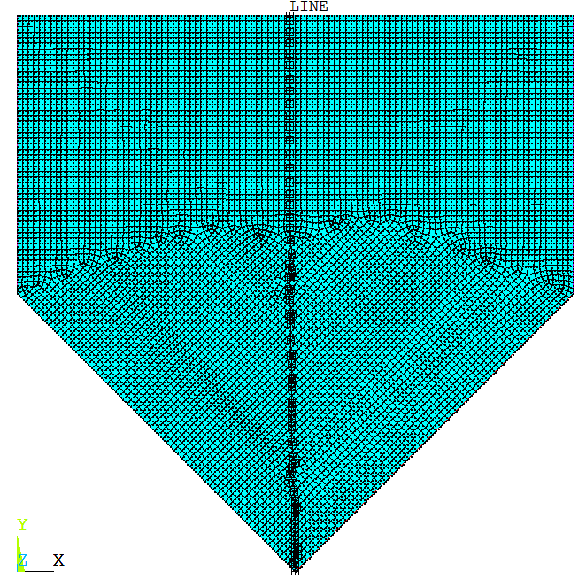

Figure 19

CASE 4

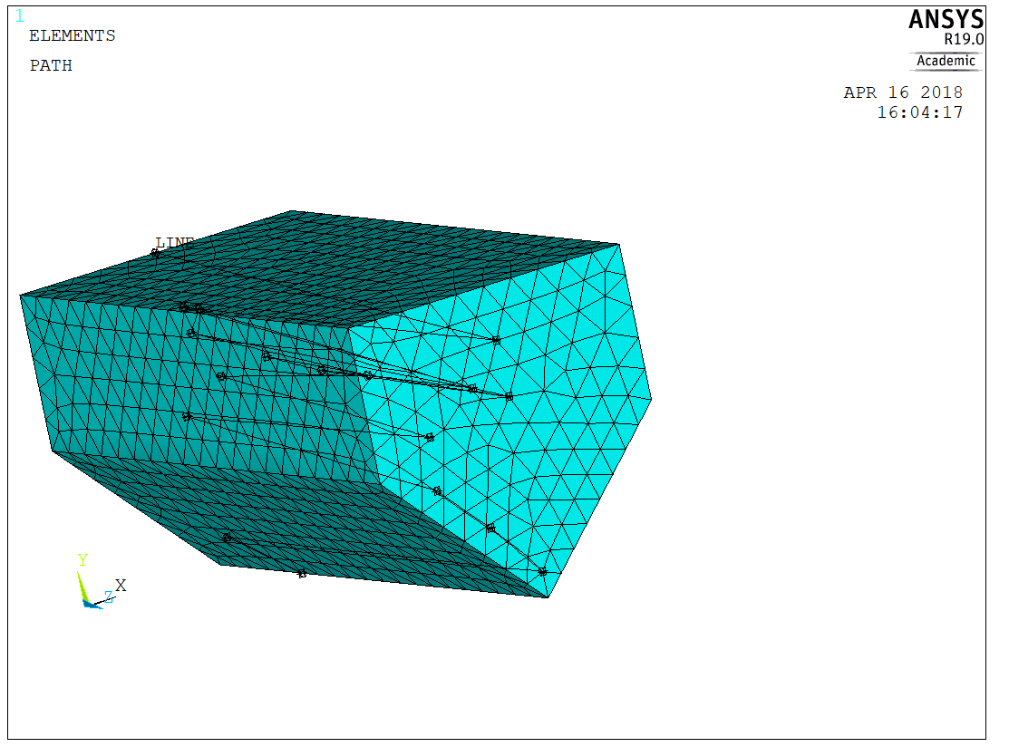 Figure 19

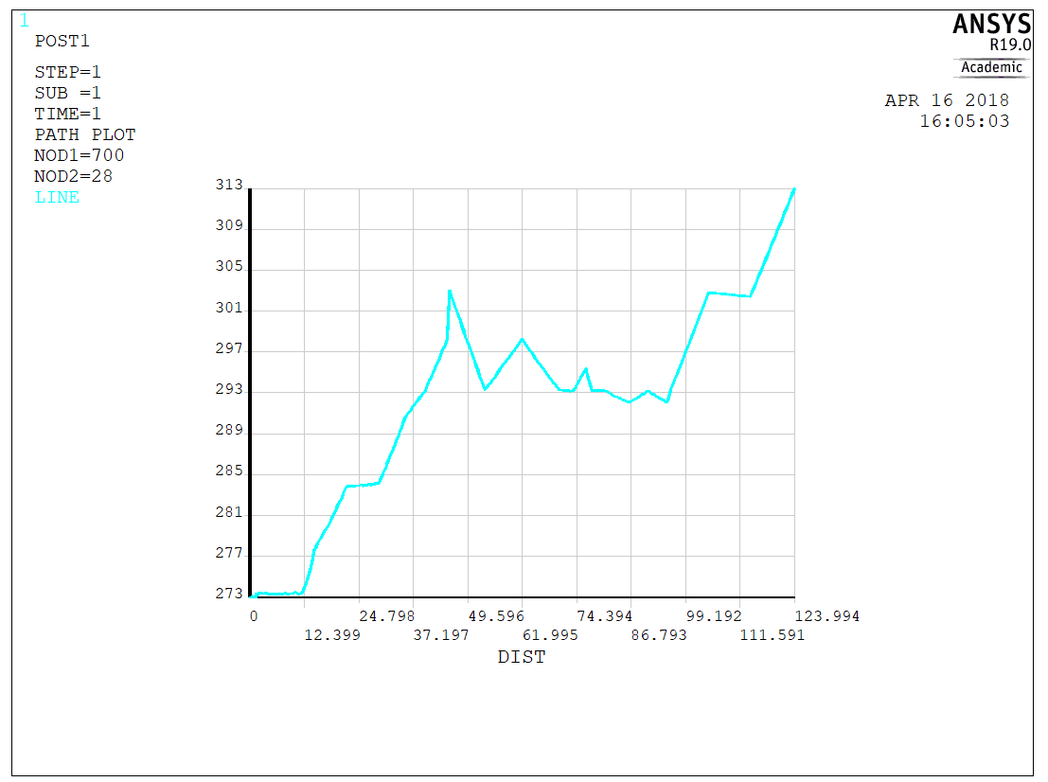 Figure 20

CASE 5

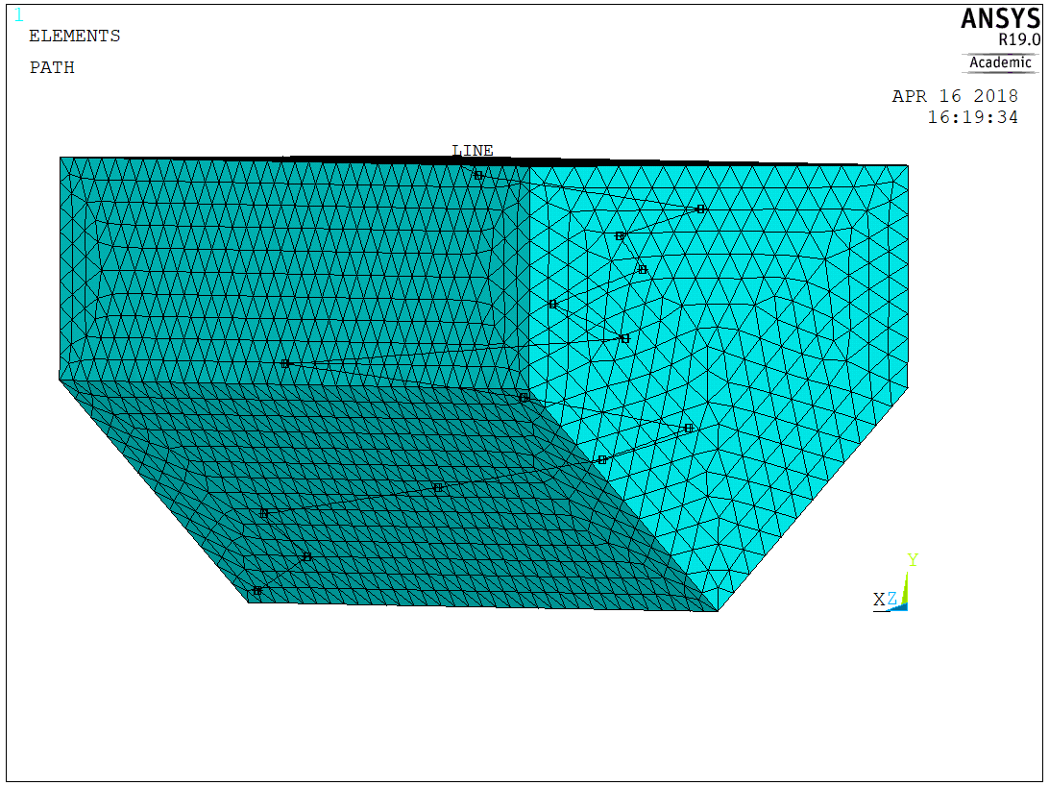 Figure 21

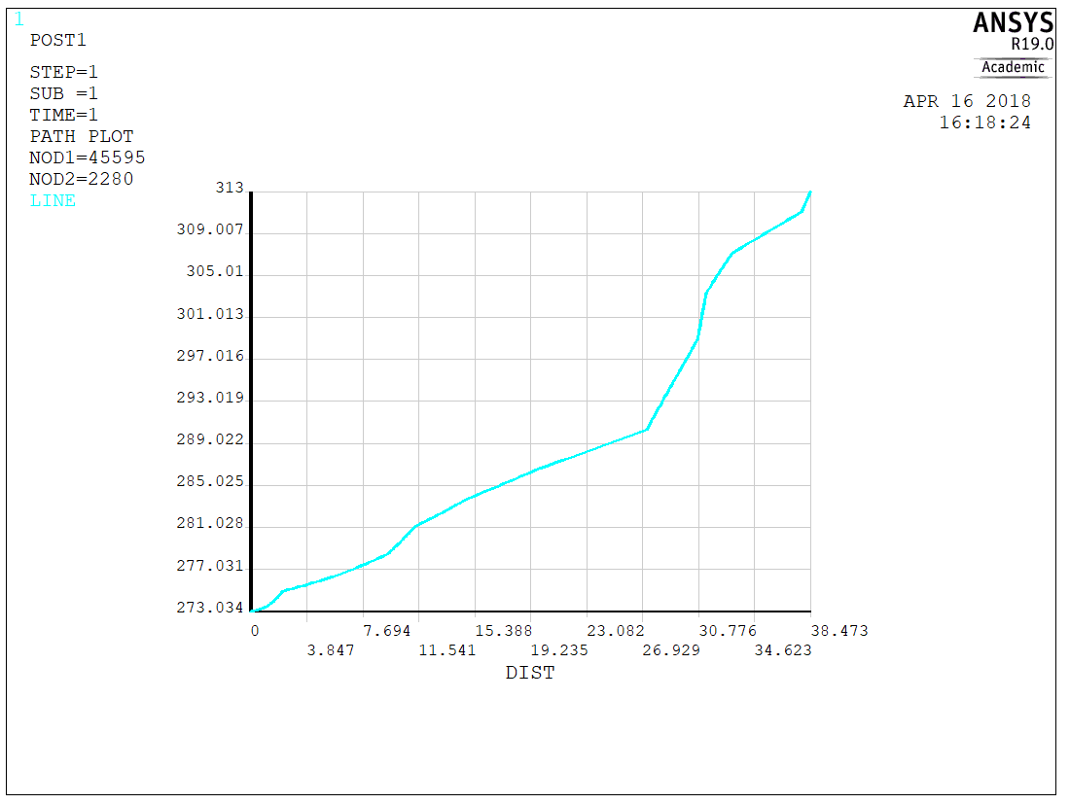 Figure 22

**CONTOUR PLOTS FOR THE THERMAL GRADIENTS VECTOR SUM WITHIN THE ELEMENTS**

CASE 1

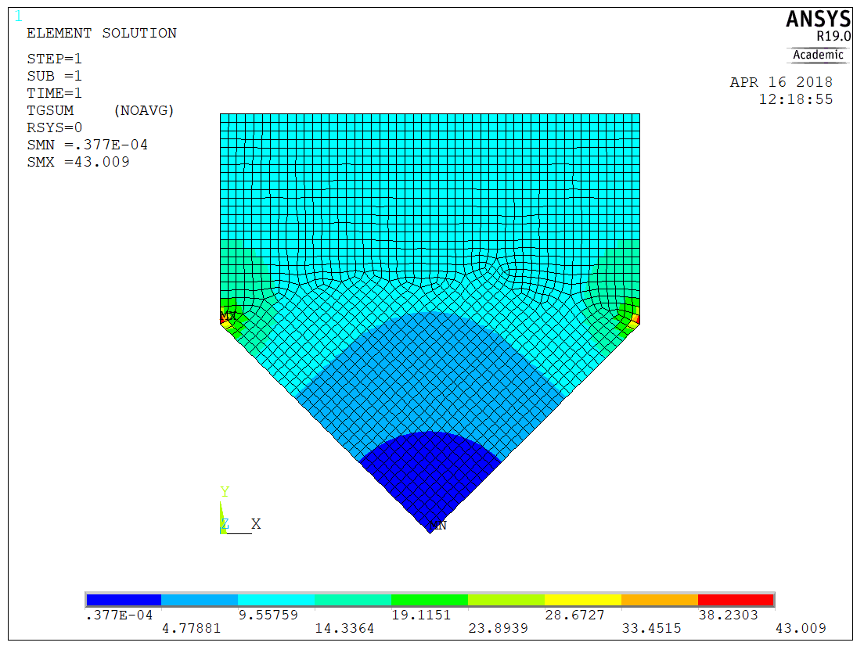

Figure 23

CASE 2

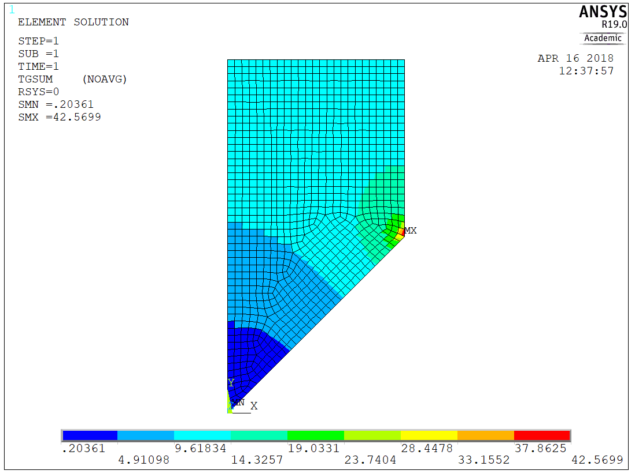

Figure 24

CASE 3

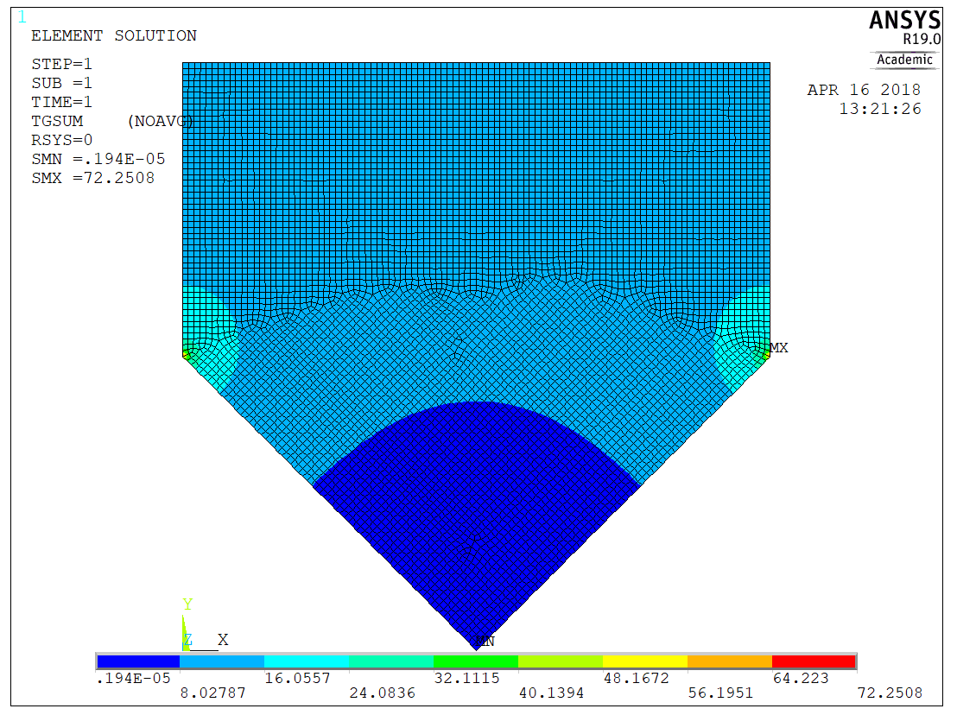

Figure 25

CASE 4

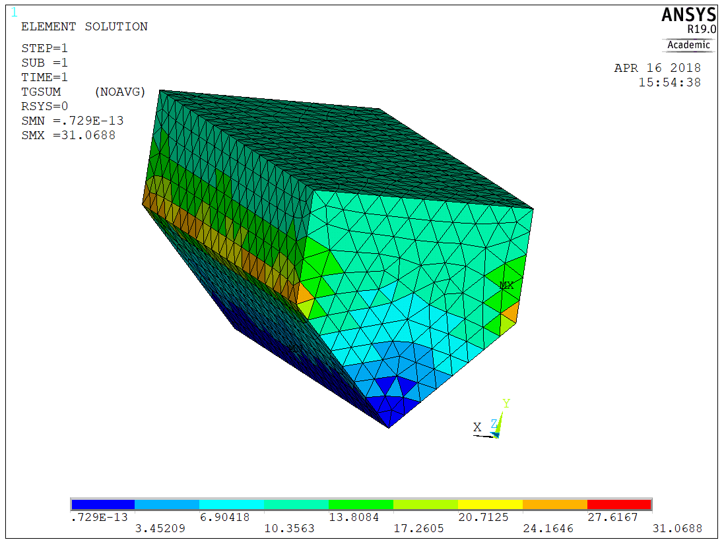 Figure 26

CASE 5

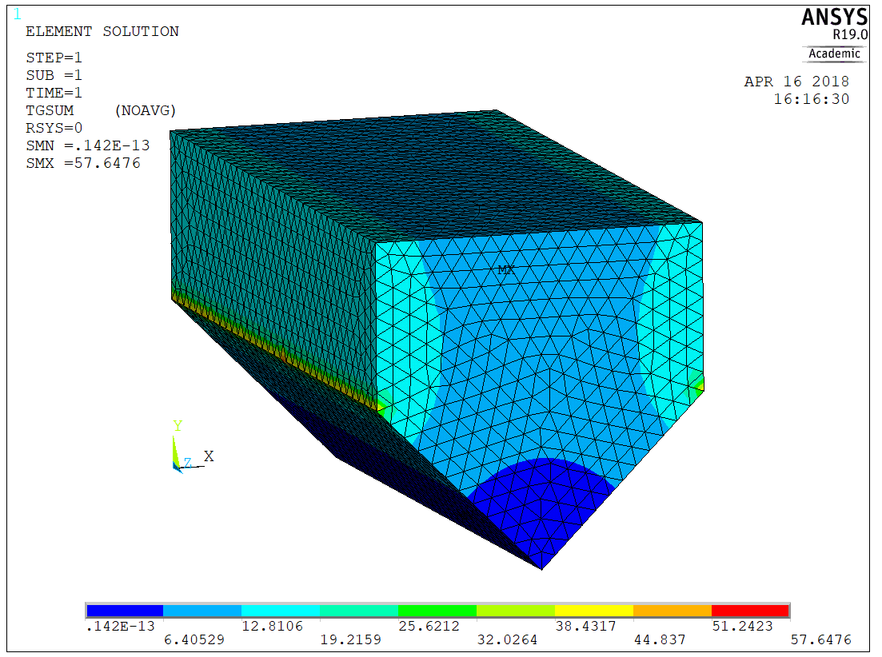

Figure 27

**Discussion**

All results presented in the previous section match with expectations. As we can see in the deformation results, the simulation results match with what we have expected for the two independent cases. Additionally, the maximum stress for the case 1 it is found in the front drop-out, as well as in the case 2. For this second case, I am a bit skeptical about the Von-Mises stress being the maximum at that location. Finally, I would like to highlight the fact, that the second cases is a more critical case than the first one.

For convenience, FEA is recommended for these types of problems. The complexity of the problem does not reach an extreme level. Some other methods can be applied to solve these type of structures as Hardy Cross method, but it will be very time consuming.

The best design in this project is the design number 1 because meets the requirements. However, I think this design is oversized and a more efficient design can be found.

The used material is aluminum because it is an affordable material with great mechanical properties. Other materials can be found for this type of applications such as carbon fiber; however, the price is very high.

Other tests must be done on these type of frames before they are manufactured, some of them are:

1. Fatigue test. (For testing the life time of the frame)
2. Case 1 and case 2 in a dynamic test.
3. Testing the maximum bending moment under different loads.
4. Welding analysis. (To identify micro-fissures )
5. Quick impacts.

Finite element analysis give us a good approximation of the problem in a very short time. This is the main motive why FEA is used for engineering design. Results can be reached and checked without an excessive consumption of time. This allows us to iterate the results and change the design till converging with a very efficient final design. However, the results of this simulation are not exact. For exact results we will need to refine the mesh to the point that simulations can take a long time to solve the problem.

**Conclusion**

Once again the finite element analysis of this problem is not a strict requirement; however, it will be more than helpful the use of a FEA software to analyze the problem, even though it could be calculated by mechanics of material, it will be tremendously tedious and tricky.

The more number of elements the better approximation we obtain.

In essence, we could say that FEA methods are very recommended for this problem.